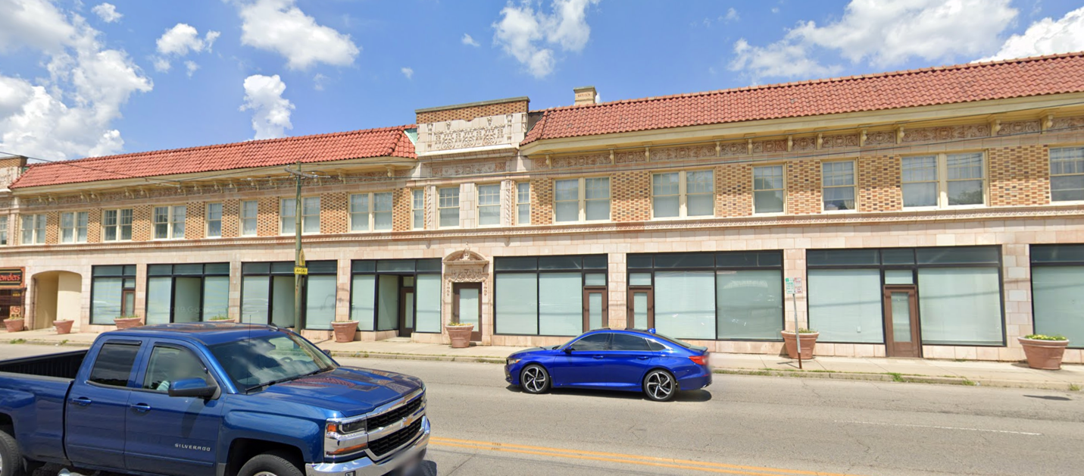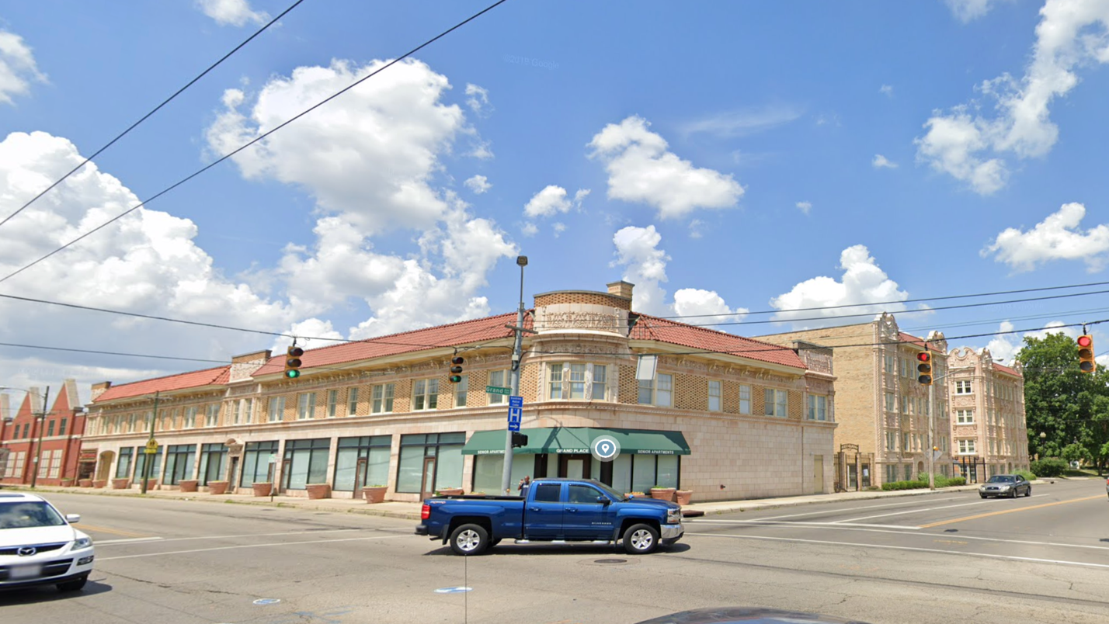

Examples of Successful Façade Renovation at Salem and West Grand
And the Setzer Building on West Third Street

Conservation of Historic Facade, Construction Magazine, July 2020
https://www.structuremag.org/?p=16131

Marc Giles Architect, Olde Town Hall, Talmadge, Ohio https://www.arrcinc.com/team/mark-gilles
Schooly, Caldwell Architects, Columbus, OH recommended by Preservation Ohio https://www.schooleycaldwell.com/historic-preservation

Grants for façade assessment from the Pipeline Initiative of the Ohio Preservation Office and the Ohio Development Services Agency https://www.limaohio.com/news/457860/discovering-whats-under-a-wapak-buildings-facade

Power Construction, Chicago, Illinois Five Approaches to Balancing Authenticity, Budget and Timline
https://www.powerconstruction.net/news/chicago-historic-facade-restoration

